**IMPLEMENTATION OF A MAP REDUCE BASED CONTEXT AWARE RECOMMENDATION ENGINE FOR HEALTH CARE**

Bharatkumar M (1MS12CS017), Bailore Avinash (1MS12CS016)

Chandrashekar B(1MS13CS405), Raghavendra Naik(1MS12CS081)

DEPARTMENT OF COMPUTER SCIENCE, MSRIT, BANGALORE

**ABSTRACT**: healthcare systems will monitor patients as they maintain their normal everyday activities, in order to warn the patients or healthcare workers of problems as well as collecting data for trend analysis and medical research. A healthcare application may bring about severe network traffic as patients, biomedical signals, sampling rates increase. This traffic could produce some end-to-end delay. A compression of sensing data may be a solution, but it can also cause an increment of processing time and unexpected errors in healthcare service. In this paper we proposed a component based development framework for context-aware processing for u-healthcare application that can reduce network traffic, by using the framework, the information gathered from the environment and patient condition will be process using the designed component development and send to the user or hospital in form of different services (1) alert message service, (2) location information services (3) condition of patient services. We also present the sensor interface framework and multi-purpose gateway to process the contextual data and send to medical centres, hospital or patients mobile device as u-healthcare services

KEYWORDS: context-aware systems, healthcare, component based development

**INTRODUCTION:**

Healthcare systems will monitor patients as they maintain their normal everyday activities, in order to warn the patients or healthcare workers of problems as well as collecting data for trend analysis and medical research. The continuous monitoring of the health record would give a better diagnosis, treatment and emergency services. The ubiquitous computing needs many technologies such as network, application, software platform, and device standardization. Users should be able to access the applications conveniently as well as safely. The healthcare service out of applications may provide ubiquitous medical service for human beings. If component technologies are developed, healthcare will be improved. An advance in various sensors is worthy of notice. There are many examples about the biomedical sensors such as blood ingredient detection sensor, environment monitoring

sensor, body signal analysis, and activity tracing

technologies.

There are healthcare applications based on sensor network that can notify the doctor of urgent messages of heartbeat, oxygen saturation, and electrocardiogram or monitor health status through badges attached on their clothes.

The monitoring sensors or devices for a living body must automatically send warning signals to clinic team whenever some events arise. A healthcare application may bring about severe network traffic as patients, biomedical signals, sampling rates increase. This traffic could produce some end-to-end delay. A compression of sensing data may be a solution, but it can also cause an increment of processing time and unexpected errors in healthcare service. This end-to-end performance in u-healthcare can be improved by transmitting differential signals or changes since the last transmission. Another way is to use the current context of the patient. For example, some trivial vital signs can be skipped by a medical information application. Also this context recognition could let clinic team provide better treatment for the patient. To address these limitations, we proposed a component based development framework to process the context data from the patient and process these contexts to for healthcare services (a) alert messages, (b) location information (c) condition of the patient.

**CONTEXT-AWARE APPLICATION IN HEALTHCARE:**

Context-aware mobile [agents](http://en.wikipedia.org/wiki/Software_agent) are a best suited host implementing any context-aware applications. Modern integrated voice and data communications equips the hospital staff with smart phones to communicate vocally with each other, but preferably to look up the next task to be executed and to capture the next report to be noted.

However, all attempts to support staff with such approaches are hampered till failure of acceptance with the need to look up upon a new event for patient identities, order lists and work schedules. Hence a well suited solution has to get rid of such manual interaction with a tiny screen and therefore serves the user with automated identifying actual patient and local environment upon approach, automated recording the events with coming to and leaving off the actual patient, automated presentation of the orders or service due on the current location and with Supported documenting the required information keying in a minimum of data into prepared form entries.

**DELIVERING HEALTHCARE SERVICES:**

The context is generated from the patient environment and sends to the mobile device. The mobile device process the receive data as context. These contexts information will then be process and send to the server. The server read the data and search for the appropriate component from the repository. For example, the sensor sends the signal of vital signs of the patient and detected to be in trouble, then the context aware information will be send from user’s mobile device to the nearest hospital or call the emergency number to rescue the patient. This context-aware information on the process is raw data which needs to be process and transform into information that the person can understand. Therefore, to efficiently process these data, the designed framework which is an active repository for running system will be used. By using the framework, the information gathered from the environment and the patient condition with the help of sensor devices, will be process using the designed component based development and send to the user or the hospital as organized information. This information can be in form of the following:

**Alert Message Services**

* 1. Low Danger
  2. Medium Danger
  3. High Danger

1. **Location Information Services**
2. **Condition of the Patient Service**

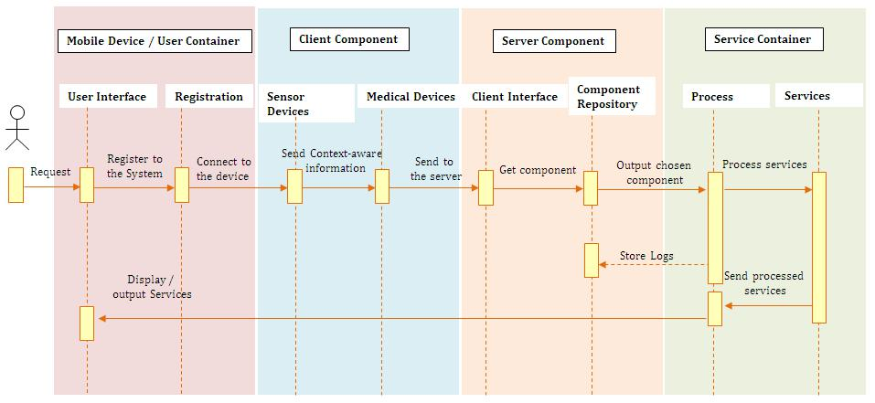

Sequence Diagram of the Proposed U-Healthcare Application

In this section we take medical records of large number of patients and then write the MapReduce program/algorithm that find the occurrence of patient medical history in a large file.

package org.myorg;

import java.io.IOException; import java.util.*;

import org.apache.hadoop.fs.Path; import org.apache.hadoop.conf.*; import org.apache.hadoop.io.*; import org.apache.hadoop.mapreduce.*; import

org.apache.hadoop.mapreduce.lib.input.FileInputFo rmat;

import org.apache.hadoop.mapreduce.lib.input.TextInputFo rmat;

import org.apache.hadoop.mapreduce.lib.output.FileOutput Format;

import org.apache.hadoop.mapreduce.lib.output.TextOutput Format;

public class medicalrecord { public static class Map extends

Mapper<LongWritable, Text, Text, IntWritable> { private final static IntWritable one = new

IntWritable(1);

private Text word = new Text();

public void map(LongWritable key, Text value, Context context) throws IOException, InterruptedException {

String line = value.toString(); StringTokenizer tokenizer = new

StringTokenizer(line);

while (tokenizer.hasMoreTokens()) { word.set(tokenizer.nextToken()); context.write(word, one);

}

}

}

public static class Reduce extends Reducer<Text, IntWritable, Text, IntWritable> {

public void reduce(Text key, Iterator<IntWritable> values, Context context)

throws IOException, InterruptedException { int sum = 0;

while (values.hasNext()) {

sum += values.next().get();

}

context.write(key, new IntWritable(sum));

}

public static void main(String[] args) throws Exception {

Configuration conf = new Configuration();

Job job = new Job(conf, "medicalrecord"); job.setOutputKeyClass(Text.class); job.setOutputValueClass(IntWritable.class); job.setMapperClass(Map.class); job.setReducerClass(Reduce.class);

job.setInputFormatClass(TextInputFormat.class);

job.setOutputFormatClass(TextOutputFormat.class); FileInputFormat.addInputPath(job, new

Path(args[0])); FileOutputFormat.setOutputPath(job, new

Path(args[1]));

job.waitForCompletion(**true**);

}

}

Java source code for MapReduce to find the occurrence of patient’s medical data

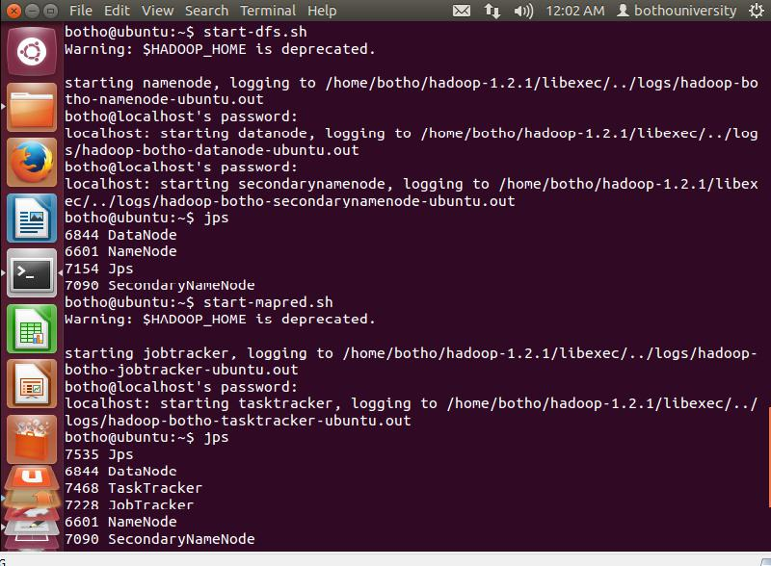

**RESULTS:**

**PRELIMINARY DATA PREPARATION**

This work can be involved dummy patient health patient dataset collected in the HSCIC (Health & Social Care Information Centre) contains fields of patient name, patient id, date of birth, Email id, gender, disease, and disease id. That data can be maintained in the format of CSV (Comma Separated Value file.

Fig: Data Preparation Procedure

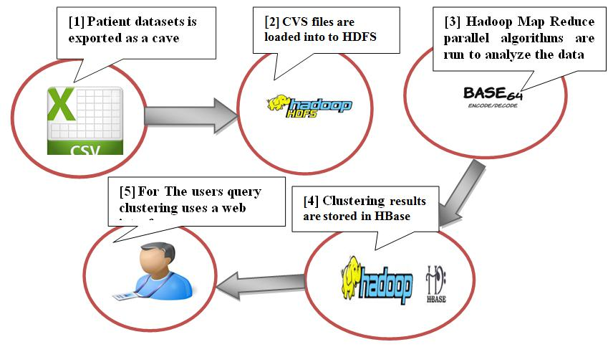

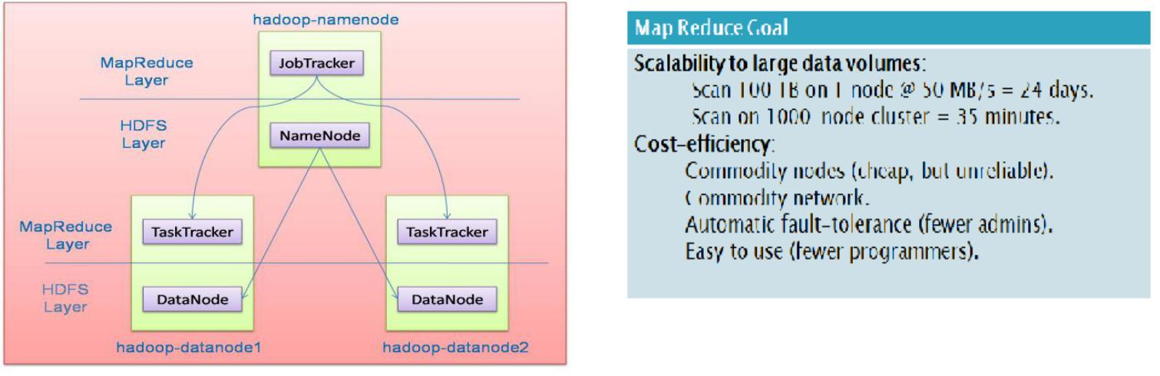

Fig: map reduce goal

We have first started with Hadoop Services such as Name node, data node, Job tracker, task tracker and Secondary name node. All 5 daemons should be running in order to work further with hive, and scoop.

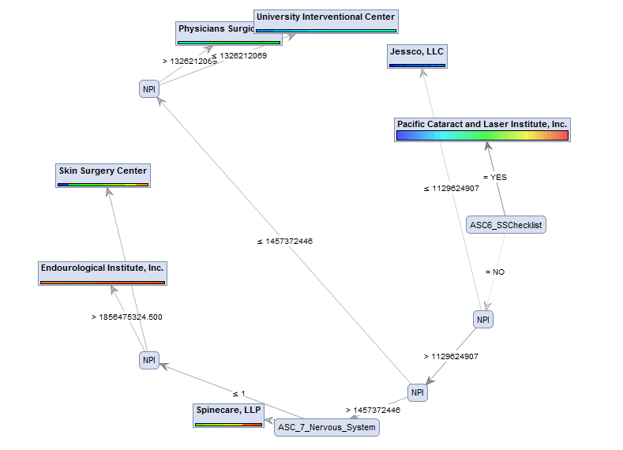

fig. Output graph

**CONCLUSION:**

In this paper we proposed a context- aware framework for u-healthcare system based on component based - development. This framework processes the context from surroundings. We also present the sensor interface framework and multi-purpose gateway to process the contextual data and send to medical centres, hospital or patients mobile device as u-healthcare services. By using the framework, the information gathered from the environment and patient condition will be process using the designed component development and send to the user or hospital in form of different services (1) alert message service, (2) location information services (3) condition of patient services. In this paper we have taken bulk medical records of unstructured data and then uses hive, to import the data into Hadoop and then process it and further this is exported to external databases on cloud for further analysis.

**REFERENCES**

[1] Dean J, Ghemawat S: MapReduce: simplified data processing on large clusters. Commun ACM 2008, 51(1):107–113.

[2] Thusoo A, Sarma JS, Jain N, Shao Z, Chakka P, Anthony S, Liu H, Wyckoff P, Murthy R: Hive: a warehousing solution over a map-reduce framework. Proc VLDB Endowment 2009, 2(2):1626–1629.

[3] Nguyen AV, Wynden R, Sun Y: HBase, MapReduce, and Integrated Data Visualization for Processing Clinical Signal Data. In AAAI Spring Symposium: Computational Physiology: 2011; 2011.

[4] AWS | Amazon Elastic Compute Cloud (EC2)

Scalable Cloud Hosting. [http://aws.amazon.com/ec2/]